**Speaking Presentation**

**2016**

**Dan Kingsbury, DDS**

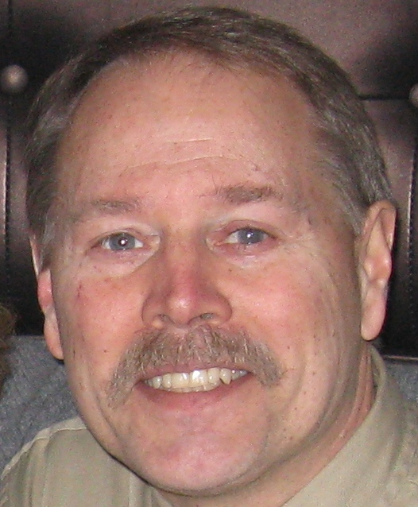

***Dan Kingsbury, DDS - Speaking Presentation***

***Advanced Business Management for Dentists AGD – CERP Provider presents Green Dentistry: This is a Must Conversation and Green Angel Training***

**Box 154, Roberts Creek, BC, V0N2W0, Canada**

**604 886-9899**

**dankingsburydds@greenangeltraining.org**

|  |  |
| --- | --- |
| greenangel_logostacked.jpg | **Kingsbury on**  **“Green Dentistry: This is a Must Conversation”**  THE FUTURE IS COMING AND IT WILL BE AMAZING, or not - IT’S UP TO US! |

Wouldn’t dentistry be so much easier if your patients knew what you know? If they came to your office already understanding that what happens in the mouth happens elsewhere in their body and in our environment, and that they and their environments may not be as healthy as they once thought they were?   
  
If only they could see for themselves:

* What a healthy mouth and a healthy environment is and then identify with their ailments and their likely future
* The connection between their internal health and the external health of our environment
* How you care for their total picture of health promotion, the socio-economic and the biologic in addition to disease prevention and treatment

**Then they would not only accept treatment (causing your collections to skyrocket), they would refer their friends and family (causing your new patients to bloom), and not only would they become “healthy,” but their whole community would too.**

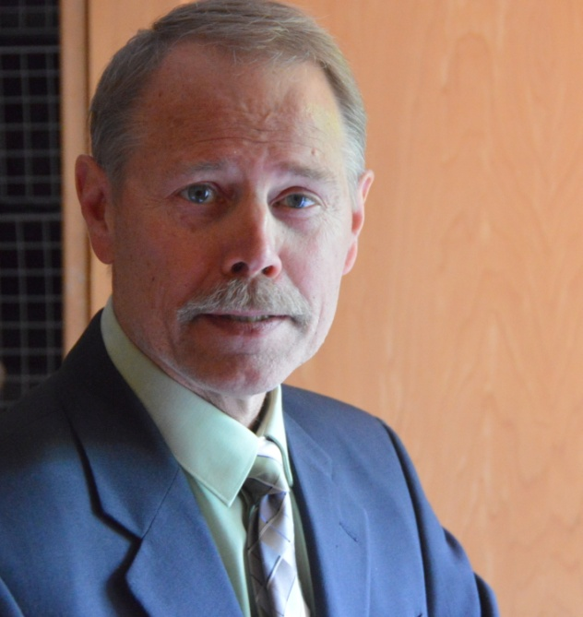Implementing new sustainable technology, new information about climate change, antibiotic resistance, or neurodevelopmental toxins, involves more than buying and installing a product - it also requires changing the context you are operating in, the status quo!

As a dentist who is a life coach, I see people resist change for a variety of reasons. Doctors and staff are especially resistant to change, and this is the challenge. The actual use of sustainable technology and behaviour is easy, it’s the mind-set of the old comfort zone that’s the challenge.

Short Bio:

Dr. Dan Kingsbury is the co-founder of the Dental Coaches Association, an AGD-PACE Provider through Advanced Business Management for Dentists (ABMD), a Suzuki Elder, founding partner and program manager of Green Angel Training Program – Basic and Professional, and an advocate for children’s environmental health. He is also the co-creator of [The Jellyfish Project Society](https://www.youtube.com/watch?v=cSlpJwRz7g0), a non-profit offering school presentations on ocean sustainability, climate change and environmental stewardship as well as classroom eco-audit learning resources for Grades 6 – 12.

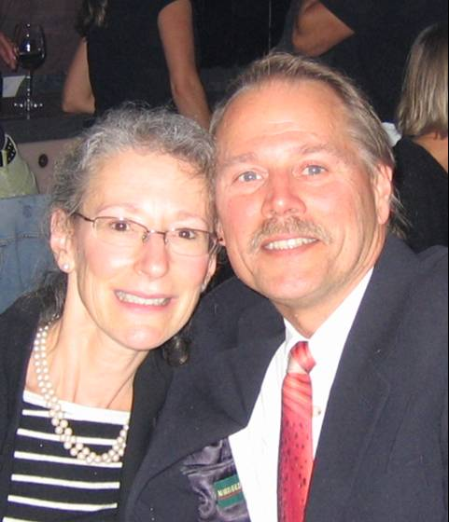Dr. Dan Kingsbury

The Kingsbury family name has been a prominent name in dentistry for over 100 years. He has seen the past, he lives in the present, and he is one of dentistry’s top experts on Green Dentistry, i.e., changing the context dentistry is operating in. He takes a stand against the idea of multi-practice entrepreneurial dentists baited by the carrot of the ‘25 million dollar,’ high-tech, price-driven practice. He is for community, trust-based dentistry, treating both the individual and the community as the patient. He is for treating the whole environment of the patient both inside and outside their mouth. He is for sustainable seafood, GMO and toxin-free choices in consumer products. He is for the *Rights of the Child* to a healthy environment with clean water, fresh air and healthy food. He is for taking on the *One Tonne Challenge* (reducing residential energy use by 10% via sustainable options). In summary, he is for people, planet and profit.

His high touch, high tech, energy-saving program and insight into sustainable practice operations includes: behaviour, infection control, practice design, equipment and sundry supplies information. Advising and being counsel to major dental suppliers in North America on the subject of “Green Dentistry” means that he can provide the tools and training needed to make wise technological and environmental decisions, helping to save time, money, people and planet.

Choose from Dr. Kingsbury’s most popular presentations below, or contact our office to customize a presentation for your next meeting.

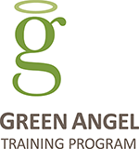

**(604) 886-9899** [**dankingsburydds@greenangeltraining.org**](mailto:dankingsburydds@greenangeltraining.org)

**Continuing Education Courses**

**Course One: Lecture**

Green Dentistry: This is a Must Conversation

2.5 and 5 hour seminar – the Art and Science; the Heart and Soul

**Intended audience:** dentists, hygienists, CDAs, office staff, lab staff

**Suggested format:** half or whole day lecture

**Course Two: Home Study**

Online - Green Angel Training – Dental Health Professionals

Includes - Green Dentistry: This is a Must Conversation

8 hours of online CE on patient education, motivation and new patient generation and on conversations that matter: climate, food, neurodevelopmental toxins, our children’s health at risk, hygiene, mid-level disinfectants, antibiotic resistance, sustainable choices, community outreach, school resources, and more.

**Note:** There is also **Green Angel Training – Basic** for the lay person (your patients) to educate, motivate and engage their trust for referrals. Now your patients can learn what you are learning; it’s part of seeing the patient as both the individual and the community, and treating both at the same time through conversations that matter - conversations that help create healthy, sustainable futures.

**Course One: Lecture Detail**

Green Dentistry: This is a Must Conversation

2.5 and 5 hour seminar

**Description - Long version**

Of course, Green Dentistry is what you think it is - conservation of energy, reducing waste and water use. It is also about behavior and choice, office design and selecting equipment and supplies that reflect sustainable values like reduced processing chemicals (i.e. digital x-rays), reduced toxic effluents and waste (i.e. amalgam and mercury separators, gypsum recycling, etc.), reduced use of plastic over paper options (i.e. paper cups and paper products sourced from sustainable sources) and sourcing products that do not have known carcinogens or neurotoxins in their ingredients (i.e. triclosan in some of Colgate’s toothpaste to butyl cellosolve in Cavicide, a neurotoxin in this mid-level disinfectant) etc.

**Kingsbury on**

***Green Dentistry: This is a Must Conversation***

THE FUTURE IS COMING AND IT WILL BE AMAZING, or not - IT’S UP TO US!

(604) 886-9899

[dankingsburydds@greenangeltraining.org](mailto:dankingsburydds@greenangeltraining.org)

[www.greenangeltraining.org](http://www.greenangeltraining.org)

You will discover a medical model called “Health Promotion Theory” used in public health where the determinants of health are what we know, i.e. the health care system with disease prevention and treatment, and also what we don’t know, i.e. the socio-economic, the environmental and the biologic/genetic endowments that are responsible for 75% of the determinants of health outcomes. Also, in this theory, is the concept of treating the individual and the community as the patient. This is a completely new paradigm of health, and at the very least a new expression of dentistry.

Along this theme of Green Dentistry are environmental factors that affect the health of entire populations (communities) as well as individual patients (i.e. climate change, antibiotic resistance, and neurodevelopmental toxins). These themes and their solutions are what my seminar is about.

**Learning outcomes for Green Dentistry: This is a Must Conversation**

1. Learn about a new expression in dentistry called the Health Promotion Theory
2. Learn that leadership is not about “how” but “who”
3. Learn how climate change and environmental factors are responsible for 25% of health issues
4. Learn how fear, stress, poverty, unemployment and social isolation are all barriers to health and are a contributing factor (45%) of dental disease
5. Learn about the silent pandemic of neurodevelopmental toxins and how more could be done about antibiotic resistance
6. Learn what you and your patients can do to avoid neurotoxins and live more sustainably

What is Green Dentistry? At the very least, Green Dentistry is a new expression of dentistry where Health Promotion Theory and empathy are expressed in addition to disease prevention and treatment, as crucial to optimum patient outcomes.

Further to what a green dental practice looks like, in terms of its behavior, office design, equipment and supplies, learn about how climate change, antibiotic resistance and neurodevelopmental toxins are a silent pandemic affecting your whole community as much as your individual patient. Learn what you can do to connect to this “Must Conversation” and increase your patient referrals.

**Description - Short version:**

This course is about what you would expect: conservation, savings, and benefits of reduce, reuse, repurpose, and refuse. Additionally, it is about patient education and motivation from Health Promotion Theory, which includes seeing your patient not only as the individual patient, but also as the community. Keen awareness of disinfection protocols, the rise of antibacterial resistance, and how to avoid developmental neurotoxins, and how to live more sustainably by ‘informed choice,’ is what this course is about. Green Dentistry: this is a Must Conversation provides the kind of leadership necessary for these changing times. Your patients will talk about your interesting and relevant office talk, and people will want to come in.

URL Key [www.greenangeltraining.org](http://www.greenangeltraining.org)

Pacific Dental Conference [www.pdconf.com/cms2015/attached/handout/pdf/14.pdf](http://www.pdconf.com/cms2015/attached/handout/pdf/14.pdf)

**Course Two: Home Study Detail**

ONLINE: Green Angel Training – Dental Health Professionals

8 hours online CE <http://www.greenangeltraining.org/dentalhealthprofessional-ce/>

**Description - Long Version:**

Learn about “**Health Promotion** Theory” (as distinguished from **disease prevention and treatment)**, through sustainable best-practices, energy and water conservation and the potentially toxic ingredients that are in our patients' and in our own personal care products, cosmetics, home and office cleansers.

Then use your knowledge to deliver your services sustainably and to educate your co-workers and your patients on the importance of environmental (epigenetic) health promotion.  These important conversations will contribute to staff and patient health, retention, and new patient generation.

One of the challenges in health care, in addition to prevention, is health promotion. Patient education is getting to the root causes of disease, while health promotion, as distinguished from disease prevention, is connecting your patients to information that inspires behavioral change towards optimum health outcomes.

**Green Angel Training – Dental Health Professional** facilitates conversations that include your patients’ home, work and school environments as possible contributors to disease. The opportunity presented is to connect your patients to the role that their environment has to their health promotion, and for you and your team to connect to your patients’ personal living experience.

**Learning Objectives**

1. To motivate sustainability, health promotion, and prevention best-practices in your office, home, and community by making wise consumer and lifestyle choices
2. To identify and address current barriers in working effectively with patients around trust
3. To address key strategies in engaging your patients and staff in their future
4. To generate new patients from patient relationship-building
5. To reduce your operating costs and save your patients' money through awareness of ↓ Co2 emissions and ↑ environmental awareness
6. To provide practical, worksheet materials uniquely for patients and staff (team building exercise) to run their own Home, Office, or School Eco-Audit experience
7. Learn about a new expression in dentistry called the Health Promotion Theory
8. Learn how climate change and environmental factors are responsible for 25% of health issues
9. Learn how fear, stress, poverty, unemployment and social isolation are all barriers to health and are a contributing factor (45%) of dental disease
10. Learn about the silent pandemic of neurodevelopmental toxins and how more could be done about antibiotic resistance

**Description - Short Version**

**Part 1**

Contains videos and articles to help you build your knowledge base about toxins found in products we use and consume every day, sustainable food choices, energy, water, and waste. This information can be shared with your patients, friends, family and colleagues to generate interest for patient safety and health, facilitating conversations for sustainability, and attracting new patients with conversations that matter.

**Part 2**

* Identifying and sharing common core values
* Identifying success metrics
* *Green Dentistry: This is a Must Conversation* - PowerPoint for patient education, motivation, and referral-based conversations

**Part 3**

Introducing you to more training resources:

* Foods – pesticides – indoor and outdoor air quality – plastics - GMO
* Toxins and chemicals in everyday products and ingredient lists
* Check-lists – questions and answers on everyday chemical pollution

**Part 4**

* CE Exam
* Eco-Audit

Meet Dr. Kingsbury\_\_\_\_\_\_\_\_\_\_\_\_\_\_\_\_\_\_\_\_\_\_\_\_\_\_\_\_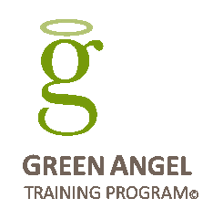

What you are about to hear is straight forward and to the point, penetrating and well-informed. What is most distinctive about our speaker is his moral passion, and indignation at the corruption and deceptions of powerful corporations. He has deep empathy for the travails of all people, your patients, and especially for the future we are holding for our children.

His seminar is composed of reports and reflections on the status quo, on the courage and imagination of young people who are our future, and on the abuses on the part of corporations and political authorities who resist and evade our true reality, our very biology, through denial and manufactured controversy.

He will provide a kind of moral compass, to help you come to your own conclusions while spotlighting business-as-usual in systemic breakdown and while shifting the focus from the top of our society to the bottom. He wants to inspire and motivate you to join in these struggles of our own time, and to empower a U-turn generation to remake the world.

See handout for this presentation from the Pacific Dental Conference: March 6, 2015

[www.pdconf.com/cms2015/attached/handout/pdf/14.pdf](http://www.pdconf.com/cms2015/attached/handout/pdf/14.pdf)

In 2004, Dr. Dan Kingsbury, authored the CE course called, *Run Your Practice Like A Business, Think Like A CEO,* which was used in 14 dental schools. He has transitioned 180° from profit ratios and practice valuations to our current ecological crisis. He is the co-founder of the Dental Coaches Association, as an AGD-PACE Provider, a Suzuki Elder, and as a founding partner and program manager of Green Angel Training – Basic and Dental Health Professional. He is also the co-creator of [The Jellyfish Project Society](https://www.youtube.com/watch?v=cSlpJwRz7g0), a non-profit offering school presentations on ocean sustainability, climate change and environmental stewardship as well as classroom eco-audit learning resources for Grades 6 – 12.

|  |  |
| --- | --- |
| greenangel_logo.jpg | **Kingsbury on**  **“Green Dentistry: This is a Must Conversation”**  THE FUTURE IS COMING AND IT WILL BE AMAZING, or not - IT’S UP TO US! |

Most recently, in 2015, he spoke again at the Pacific Dental Conference for full CE credit on his new theme – Green Dentistry: This is a Must Conversation!

Comments were:

* “Fantastic!”
* “Maybe the best CE I’ve ever been too”
* “I had no idea…”
* ”I am a hygienist who attended your presentation at the Nanaimo DH study club this evening. I want to thank you with the utmost sincerity for the impact your presentation had on me… In regards to my practice as a hygienist, I have also been learning the power of truly listening to my patients. I have found that by doing this, people are more likely to make to decisions to improve their oral hygiene on their own and therefore take ownership of their oral health. My working relationships have improved as well as overall happiness with my career. I truly believe that the message you are sharing is of the greatest importance. I will be forever grateful for my "ah-ha!" moment tonight. Thank you for helping me grow as a human and as a being. “
* “I’m going home to tell the selection committee that they have got to get you out there to one of our meetings” etc. to which Dr. Kingsbury said, “Bring it on!”

Dr. Kingsbury is a speaker long on passion. His first real engagement was as the key-note speaker at the American Dental Association’s Practice Management and Technology Conference in 2004 in Chicago. Today his “vision” is a new expression for dentistry – green dentistry! And for all the right reasons he has pulled away from his earlier corporate mindset strategy of the love of power and money to the “love of power” and respect for our planet and our children’s future.

Dan Kingsbury, DDS

Specializing in "Dentist-to-Dentist" Coaching, Sustainability Consulting,

Distance Continuing Dental Education & Green Dentistry

[dankingsburydds@greenangeltraining.org](mailto:dan@greenangeltraining.org)

<http://www.greenangeltraining.org>

1.604.886.9899



|  |  |  |
| --- | --- | --- |
| *“The next 10 years may be the most important of the next 10,000.”*  – Sylvia Earle, Ph.D. |  | **Kingsbury says,**  *“Technology and the corporate construct are changing the world of dentistry at a remarkable pace.”* |

